Group Project Outcome

The implementation of Brute Force,Forward and Backward algorithm for Feature selection provides the data set that are most relevant and important to the model.
The final output of data set obtained after running through each of the four Machine Learning algorithms will be copied to a file and also represented in a graph.
The graph contains Features set on one axis and and importance factor in percentage on another axis.For every Machine Learning algorithm a graph is plotted. Sample of the graph format is shown below.

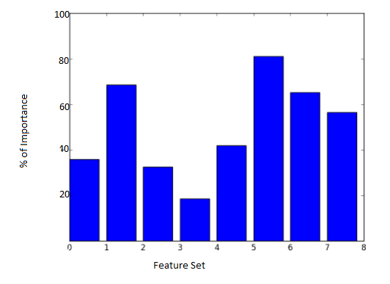
Also the output for all the machine learning algorithm are plotted in a single graph from which result can be compared.This graph is depicted below.

